The Giver Annotations Requirements
Annotation Guidelines
- Annotate while you read. Please do not read first, then go back and annotate.
- Ensure your annotations are thoughtful and intentional…they should be helpful and make sense to you later.
- One annotation per page minimum
- Ensure your symbols are consistent (make a key and stick to it).
- Explain your annotation (don’t just draw a symbol).
  - For example, if you’ve identified a simile, write simile and explain the comparison.
  - Definitions:
    - Underline context clues that could help you identify the word’s meaning. Then, look up the definition and include it in the margin.
  - Again, you should be able to refer back to your annotations and use them to help you. For example, you may want them for an upcoming essay or discussion.

Each chapter should include at least:
- One prediction
- Two new words (and definitions)
- One important detail about setting
- One important detail about new character or a change in one of the characters
- One example of figurative language
- One connection
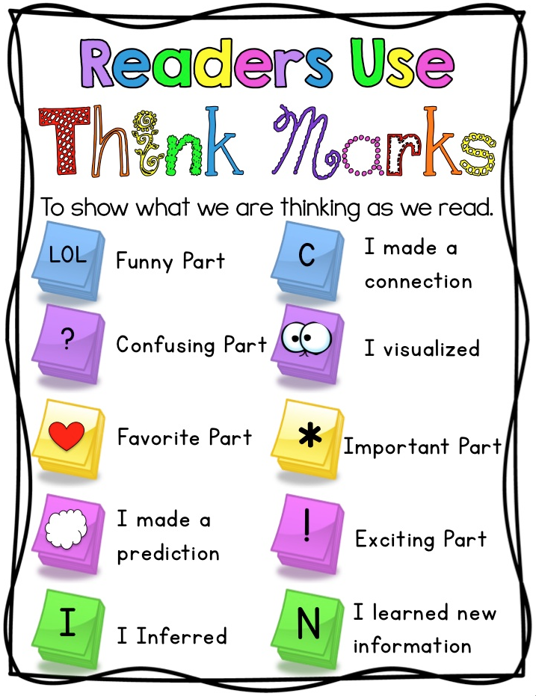
- A 3-2-1 on the last page of the chapter

At the end of each chapter, complete a 3-2-1:
3 – Important details from the chapter
2 – Things you found interesting
1 – Question you still have

Things to Consider:
- Are there any new characters?
- How are characters changing?
- Symbolism
- Figurative language
- Connections to the text
- Foreshadowing
- Genre: dystopia, utopia, science fiction

Figurative Language (Definitions and examples in blue are from Literarydevice.net)
  - Simile: Comparison using the words “like” or “as”
  - Metaphor: A direct comparison (not using the words “like” or “as”)
    - The assignment was a breeze.
    - Life is a highway. –The Rascal Flatts
  - Personification: Giving a non-human thing human-like qualities or actions
    - The waves chased each other to the shore.
    - The sun smiled down on the family picnic.
    - During the storm, the windows shuddered.
  - Onomatopoeia: A word whose sound suggests its meaning
    - Pop! Bing! Zap.
  - Imagery: Language that appeals to the senses
    - Her teeth ached from the sweetness of gooey fudge.
    - Against the dull gray pavement, her new orange shoes seemed to glow.
  - Hyperbole: Exaggeration for effect
    - My homework will take me forever.
    - I’ve never been so excited in my life!
    - That is the best joke I’ve ever heard.
  - Oxymoron: Contradictory terms appear together
    - Jumbo shrimp, seriously funny, original copy
  - Allusion
    - “…a brief and indirect reference to a person, place, thing or idea of historical, cultural, literary or political significance. It does not describe in detail the person or thing to which it refers. It is just a passing comment and the writer expects the reader to possess enough knowledge to spot the allusion and grasp its importance in a text.”
    - “Hey! Guess who the new Newton of our school is?” – “Newton”, means a genius student, alludes to a famous scientist Isaac Newton.
  - Idiom: An expression
    - He’s an open book.
    - It’s raining cats and dogs.
  - Irony: Words are used in such a way that their intended meaning is different from the actual meaning of the words.
    - Dramatic: The characters are oblivious of the situation, but the audience is not.
      - “In Snow White and the Seven Dwarves, we know that the old woman bringing the apple is the wicked queen who wants to kill Snow White, but she does not. She purchases the apple, takes a bite, and falls” (Soft Schools).
      - “Another Disney movie, Beauty and the Beast, has examples of dramatic irony. The audience knows from the beginning of the movie that the beast is a prince, but Belle does not” (Soft Schools).
    - Situational: “Situational Irony occurs when actions or events have the opposite result from what is expected or what is intended” (Soft Schools).
      - “Sara is trying to avoid a water gun fight that her brothers are having and she falls into a puddle” (Soft Schools).
      - “In the Rime of the Ancient Mariner by Coleridge, the men are surrounded by an ocean of water, but they are dying of thirst” (Soft Schools).
      - “In ‘The Necklace’ by Guy de Maupassant, a woman borrows what she thinks is a costly necklace from a friend and loses it. She and her husband sacrifice to replace it, only to learn years later that the necklace was a fake” (Soft Schools).
    - Verbal: Verbal irony involves what one does not mean.
      - For example, when in response to a foolish idea, we say, “What a great idea!”
      - The desert was as cool as a bed of burning coals.
      - The fear of long words is called “Hippopotomonstrosesquippedalio phobia.”
      - The new manager is as friendly as a rattlesnake.
      - A vehicle was parked right in front of the no-parking sign.
  - Anaphora
    - The deliberate repetition of the first part of the sentence in order to achieve an artistic effect.
      - “Everything looked dark and bleak, everything looked gloomy, and everything was under a blanket of mist.”
      - “Tell them to be good, tell them to follow their elders, and tell them to mind their manners.”

